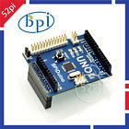**Banana Pi Accessories BPiDuino UNO Board UNO Module compatible with Raspberry Pi**

Original Design Banana Pi UNO Board compatible with Arduino UNO,which is also used in Raspberry Pi

We support wholesale. If you need more quantity or other shipping method, please contact with us.

PS: ship list: one BPI UNO board, not include Banana PI Board

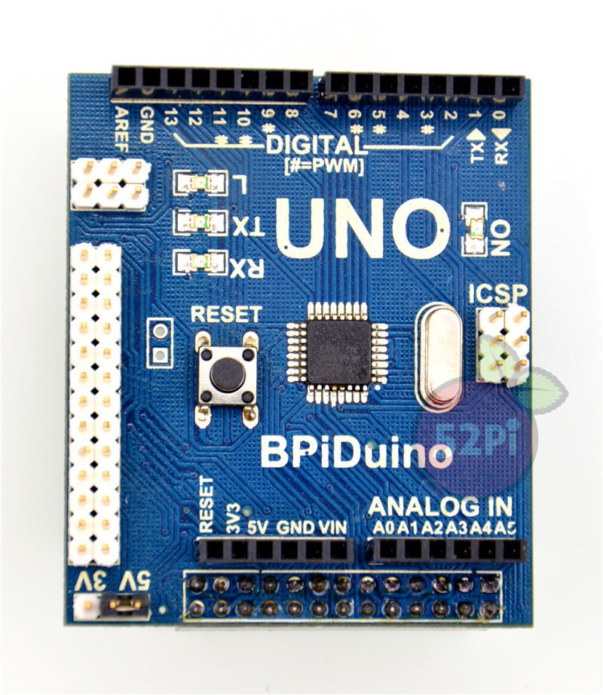

**Product Overview**

-- The module makes Banana Pi compatible with for Arduino Uno and many for Arduino Shields. There is an ATmega328 chip on the board so the module can compatible for Arduino Uno code and peripheral. This board is a combination of high operation performance of the banana pie and for Arduino flexible control performance, the combination of peripheral greatly expand the banana pie access ability and the abundance of accessories.

**Features**

-- ATmega328 chip on module

-- Compatible with for Arduino Uno

-- Switch 5V or 3.3V GPIO

-- Compatible with Processing code

-- Expand SPI of Banana Pi

**Port**

-- Banana Pi connection port

-- Banana Pi cascade port

-- for Arduino Uno GPIO

-- Electric level switch jumper

-- SPI

-- ICSP port

**Product Parameters**

-- Working voltage: 3.3V-4.5V

-- GPIO voltage: 3.3V or 5.5

-- 8 channel 10bit high resolution ADC

-- Power-down Mode: 0.1µA

-- 32K ROM

-- 2K RAM

-- −40°C to +85°C operation

**Typical Application**

-- Automatic control

-- for Arduino learning

-- Sensor control

-- 3D printer controller

-- Laser cutter controller

-- Robot controller

-- Smart home

**How to use**

-- Just insert the module to Banana Pi, like the below picture:

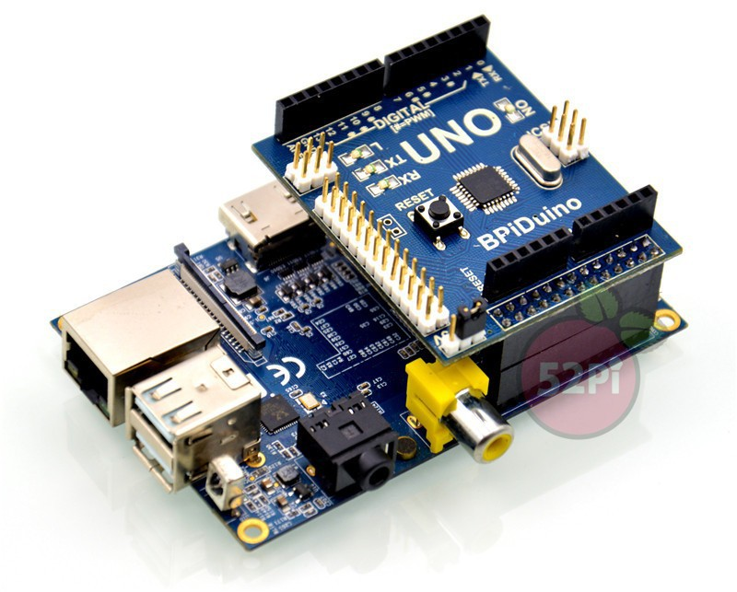

**Pin Configuration**

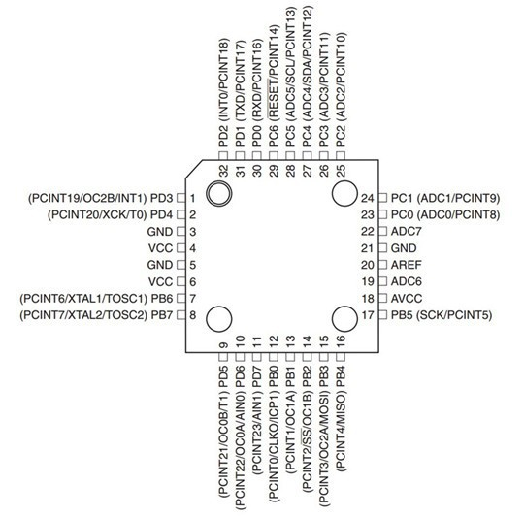

**Schematic diagram**

